Linear Regression Analysis Concepts Worksheet: Brookline Home Services
Note: This worksheet is an example for illustration purposes only. The company, scenario, and data are fictitious and were generated for this example. Your C207 Task 1 scenario and dataset are generated from your own student ID. Do not submit any part of this document. If you need assistance with your C207 Task 1, contact Gradevia on WhatsApp at +1 564 544 6924 or email Support@gradevia.com.
Practice scenario: Brookline Home Services, a heating and cooling repair company, wants to know whether faster response to service calls is associated with higher customer satisfaction. For one quarter, each of its 40 service regions recorded its average response time in hours and its customer satisfaction index, a 0 to 100 score averaged from post-visit surveys.
1. Is Linear Regression the Right Technique? (A3)
Check | Brookline example
Is the question about a relationship or prediction, not a difference between groups? | Yes: does response time predict satisfaction?
Is the dependent variable quantitative? | Yes: a 0 to 100 index
Is the independent variable quantitative? | Yes: hours
Does the null hypothesis concern a slope? | Yes: H₀: β₁ = 0
Model A3 paragraph. Linear regression is appropriate because Brookline's question asks whether one quantitative variable, average response time, predicts another, the customer satisfaction index. The null hypothesis, that response time has no linear relationship with satisfaction (β₁ = 0), is a statement about the slope of a line, which regression estimates and tests directly. The resulting equation would also let managers estimate the satisfaction index for a target response time.
2. Variables and Levels of Measurement (B1)
Characteristic | Detail | Reasoning
Independent variable | Average response time (hours) | Ratio: zero hours is a true zero, and 4 hours is twice 2 hours
Dependent variable | Customer satisfaction index (0 to 100) | Interval: differences are meaningful, but a score of 0 is the bottom of a survey scale rather than a true absence, so 80 is not "twice as satisfied" as 40
Sample size | 40 service regions | One observation per region for the quarter
The distinction between interval and ratio depends on whether the variable has a true zero (Holmes et al., 2017). Both levels are quantitative and suitable for linear regression; the level is decided by what the variable measures, not simply by whether it is a number.
3. Checking the Assumptions
Simple linear regression rests on four conditions, often remembered as LINE: a linear relationship, independent errors, normally distributed errors, and equal variance of errors (Penn State Eberly College of Science, n.d.). Two quick plots check most of them.
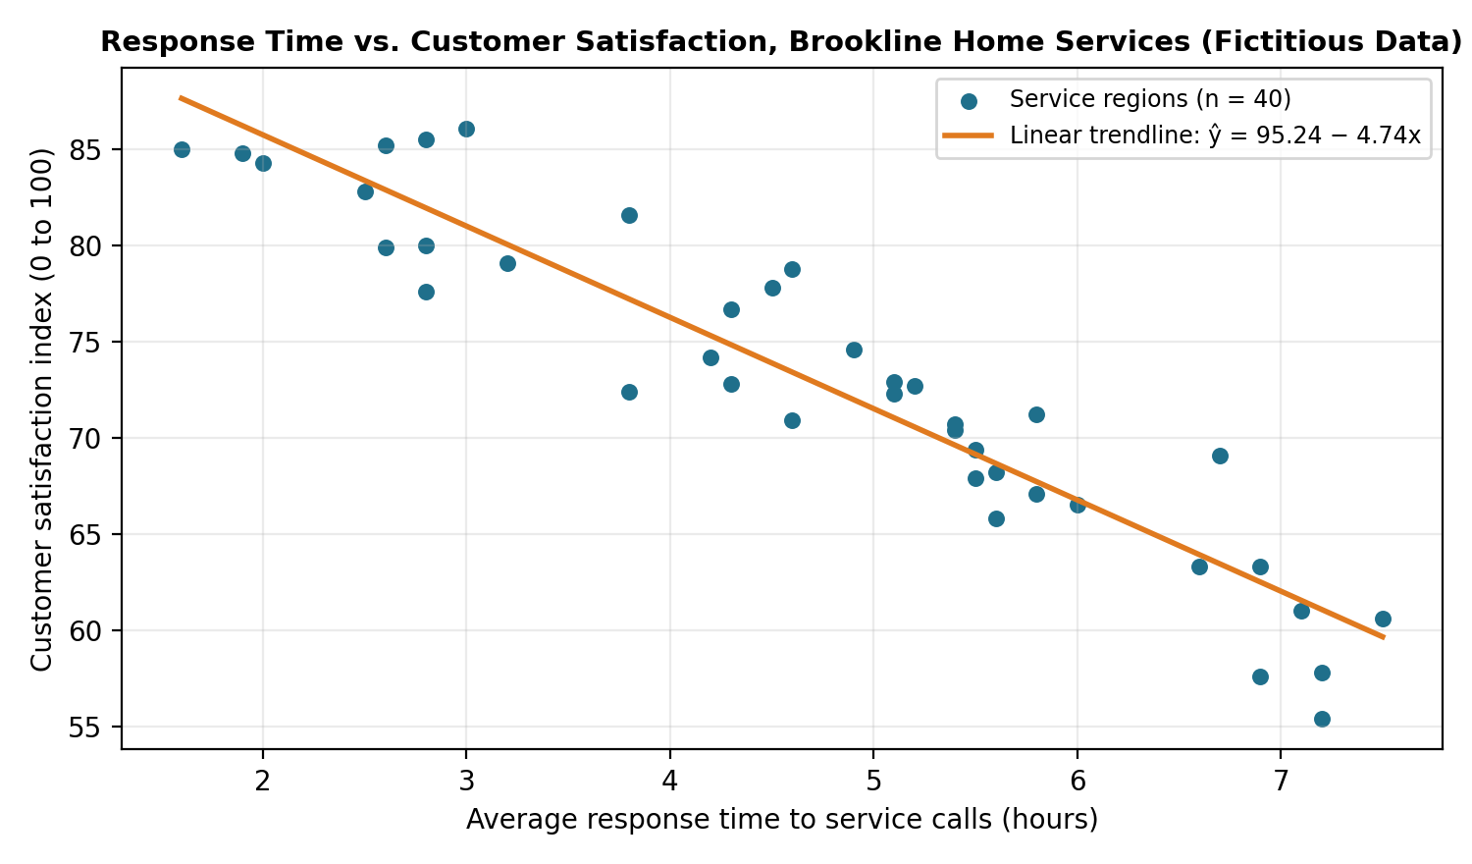
Figure 1. Average response time and customer satisfaction across 40 fictitious service regions.
Linear. The points in Figure 1 follow a straight downward pattern with no visible curve. The fitted line is ŷ = 95.24 − 4.74x, and R² is 0.880.
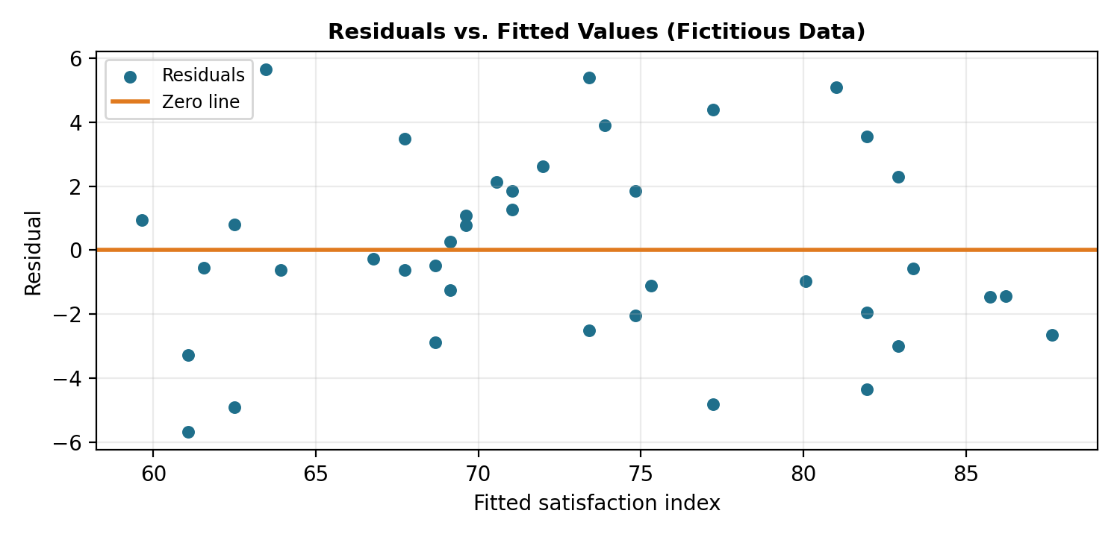
Figure 2. Residuals plotted against fitted values.
Equal variance. The residuals in Figure 2 scatter evenly above and below zero, with no funnel shape, so the spread of errors looks similar across fitted values.
Independent and normal. Each region is a separate observation, which supports independence, although neighboring regions could share conditions such as weather. A histogram of the residuals, or a normal probability plot, would show whether the errors are roughly normal.
4. Choosing a Limitation for D2
Limitation | How it applies to Brookline
Association, not causation | Regions with faster response may also have newer equipment or more experienced technicians, which could raise satisfaction on their own
Range of the data | Response times ran from about 1.6 to 7.5 hours; predictions outside that range are unreliable
One time period | One quarter of data may not reflect seasonal demand, such as summer cooling peaks
One predictor | Satisfaction likely depends on other factors, such as price and repair quality, that the model leaves out
Model D2 paragraph. One limitation is that this analysis shows an association, not a cause. Regions that respond faster may also differ in technician experience or equipment, and those differences could explain part of the higher satisfaction. If Brookline invests in faster response alone, satisfaction may not rise as much as the equation suggests, so the company should track satisfaction after any change rather than assume the full predicted gain.
References
Holmes, A., Illowsky, B., & Dean, S. (2017). Introductory business statistics. OpenStax. https://openstax.org/books/introductory-business-statistics/pages/1-3-levels-of-measurement
Penn State Eberly College of Science. (n.d.). 4.1: Background. STAT 501: Regression methods. https://online.stat.psu.edu/stat501/lesson/4/4.1

