ILLUSTRATIVE EXAMPLE ONLY. This concept map is an example created by Gradevia for illustration purposes only. It is not to be submitted for grading. It deliberately uses eight different medications from the eight assigned in NURS 6630 Week 2, so you must complete your own research and concept map. Need help or assistance with your Psychopharmacology Scavenger Hunt Concept Map? Contact us on WhatsApp: +1 564-544-6924.

Psychopharmacology Scavenger Hunt Concept Map: The Agonist Spectrum

Morgan Ellis
College of Nursing, Walden University
NURS 6630: Psychopharmacologic Approaches to Treatment of Psychopathology
Dr. Renee Callahan
September 26, 2026

Figure 1
Concept Map of the Agonist Spectrum and the CYP450 Enzyme System
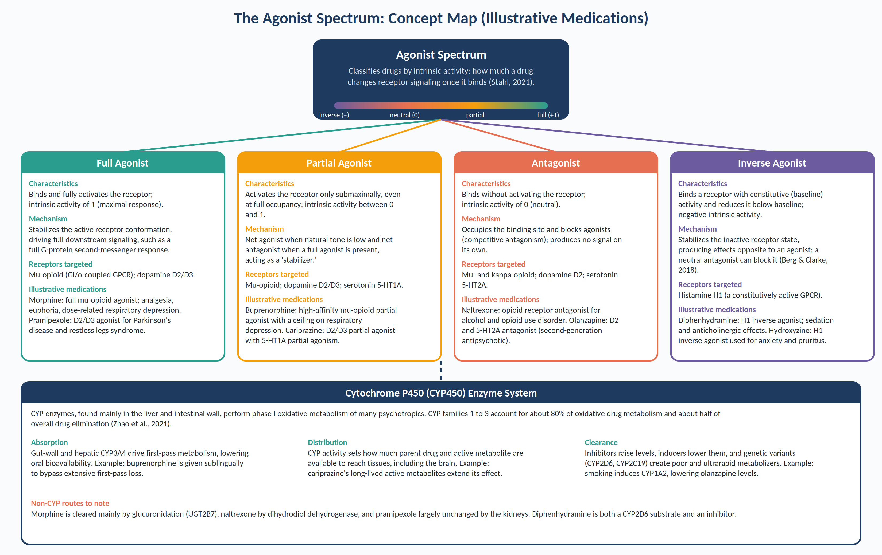
Note. Illustrative medications only. They are not the medications assigned in NURS 6630 Week 2.

Concept Map Node Details
The tables below expand each node of Figure 1 in concise, concept-map form rather than paragraphs.
Table 1
Characteristics, Mechanisms, and Receptor Targets Across the Agonist Spectrum
Spectrum position | Characteristics and intrinsic activity | Proposed mechanism | Receptor targeted (illustrative)
Full agonist | Binds and fully activates the receptor; intrinsic activity of 1 (Stahl, 2021). | Stabilizes the active receptor conformation, producing a maximal downstream signal. | Mu-opioid receptor; dopamine D2/D3
Partial agonist | Activates the receptor submaximally even at full occupancy; intrinsic activity between 0 and 1 (Stahl, 2021). | Net agonist when natural tone is low and net antagonist when a full agonist is present, stabilizing signaling. | Mu-opioid; dopamine D2/D3; serotonin 5-HT1A
Antagonist | Binds without activating; intrinsic activity of 0 (Stahl, 2021). | Occupies the binding site and blocks agonists and inverse agonists (competitive antagonism). | Mu- and kappa-opioid; dopamine D2; serotonin 5-HT2A
Inverse agonist | Binds a constitutively active receptor and lowers activity below baseline; negative intrinsic activity (Berg & Clarke, 2018). | Stabilizes the inactive receptor state, producing effects opposite to an agonist. | Histamine H1
Table 2
Illustrative Medications Applied to the Agonist Spectrum
Medication | Spectrum position | Receptor and action | Clinical relevance
Morphine | Full agonist | Full agonist at the mu-opioid receptor | Analgesia; risk of respiratory depression and dependence
Pramipexole | Full agonist | Agonist at dopamine D2/D3 receptors | Parkinson's disease and restless legs syndrome
Buprenorphine | Partial agonist | High-affinity mu-opioid partial agonist | Opioid use disorder; ceiling on respiratory depression
Cariprazine | Partial agonist | D2/D3 partial agonist; 5-HT1A partial agonist | Schizophrenia and bipolar disorder
Naltrexone | Antagonist | Mu- and kappa-opioid receptor antagonist | Alcohol and opioid use disorder
Olanzapine | Antagonist | D2 and 5-HT2A receptor antagonist | Schizophrenia and bipolar disorder
Diphenhydramine | Inverse agonist | H1 receptor inverse agonist | Sedation, allergy symptoms; anticholinergic burden
Hydroxyzine | Inverse agonist | H1 receptor inverse agonist | Anxiety and pruritus
Note. Receptor actions summarized from Stahl (2021) and Berg and Clarke (2018). These are illustrative medications, not the ones assigned in NURS 6630 Week 2.
Table 3
Role of the CYP450 Enzyme System in Absorption, Distribution, and Clearance
Pharmacokinetic phase | Role of CYP450 | Illustrative example
Absorption | Gut-wall and hepatic CYP3A4 metabolize drugs before they reach systemic circulation (first-pass effect), lowering oral bioavailability (Zhao et al., 2021). | Buprenorphine undergoes extensive first-pass metabolism, so it is given sublingually.
Distribution | CYP activity determines how much parent drug and active metabolite are available to reach tissues, including the brain; CYPs can also act at local sites (Zhao et al., 2021). | Cariprazine's long-lived active metabolites extend exposure well beyond the parent drug.
Clearance | CYPs perform phase I oxidative metabolism; families 1 to 3 handle about 80% of oxidative metabolism and roughly half of drug elimination (Zhao et al., 2021). | Smoking induces CYP1A2 and lowers olanzapine levels.
Interactions and genetics | Inhibitors raise plasma levels, inducers lower them, and genetic polymorphisms create poor to ultrarapid metabolizers (Zhao et al., 2021). | Diphenhydramine is a CYP2D6 substrate and inhibitor; strong CYP3A4 inhibitors raise cariprazine levels.
Non-CYP pathways | Not every psychotropic depends on CYP450, which changes interaction risk. | Morphine (glucuronidation), naltrexone (dihydrodiol dehydrogenase), pramipexole (renal, largely unchanged).

References
Berg, K. A., & Clarke, W. P. (2018). Making sense of pharmacology: Inverse agonism and functional selectivity. International Journal of Neuropsychopharmacology, 21(10), 962–977. https://doi.org/10.1093/ijnp/pyy071
Stahl, S. M. (2021). Stahl's essential psychopharmacology: Neuroscientific basis and practical applications (5th ed.). Cambridge University Press.
Zhao, M., Ma, J., Li, M., Zhang, Y., Jiang, B., Zhao, X., Huai, C., Shen, L., Zhang, N., He, L., & Qin, S. (2021). Cytochrome P450 enzymes and drug metabolism in humans. International Journal of Molecular Sciences, 22(23), 12808. https://doi.org/10.3390/ijms222312808

ILLUSTRATIVE EXAMPLE ONLY. This concept map is an example created by Gradevia for illustration purposes only. It is not to be submitted for grading. It deliberately uses eight different medications from the eight assigned in NURS 6630 Week 2, so you must complete your own research and concept map. Need help or assistance with your Psychopharmacology Scavenger Hunt Concept Map? Contact us on WhatsApp: +1 564-544-6924.

