C207 Task 1 Null Hypothesis Worked Example: Harbor Lane Coffee
Note: This document is an example for illustration purposes only. The company, scenario, and data are fictitious and were generated for this example. Your C207 Task 1 scenario and dataset are generated from your own student ID, so your variables and results will be different. Do not submit any part of this document. If you need assistance with your C207 Task 1, contact Gradevia on WhatsApp at +1 564 544 6924 or email Support@gradevia.com.
Practice scenario: Harbor Lane Coffee, a regional chain, wants to know whether investing in staff training is associated with more repeat customers. For one month, each of its 36 stores recorded the number of staff training hours delivered and the number of repeat customer visits, measured in hundreds.
A1. Business Question
Is the number of staff training hours per store per month a significant predictor of the number of repeat customer visits at Harbor Lane Coffee stores?
A2. Null Hypothesis
Null hypothesis (H₀): Staff training hours per month have no linear relationship with repeat customer visits; the slope of the regression line is zero (β₁ = 0).
Alternative hypothesis (Hₐ): Staff training hours per month have a linear relationship with repeat customer visits; the slope is not zero (β₁ ≠ 0).
A3. Why Linear Regression Is Appropriate
Linear regression is appropriate because the business question asks whether one quantitative variable, training hours, predicts another quantitative variable, repeat visits. The null hypothesis is a statement about the slope of a line, and simple linear regression tests exactly that: the t test for the slope, and the equivalent overall F test, show whether β₁ is significantly different from zero (Penn State Eberly College of Science, n.d.). Regression also produces an equation that managers could use to estimate repeat visits for a planned level of training.
B1. Data Characteristics
Characteristic | Detail
Independent variable | Staff training hours per store per month
Dependent variable | Repeat customer visits per store per month (hundreds)
Level of measurement | Both variables are ratio level: they have a true zero and equal intervals
Sample size | 36 stores (36 observations)
C1. Regression Output (Excel Data Analysis ToolPak format)
Regression Statistics
Multiple R | 0.9323
R Square | 0.8692
Adjusted R Square | 0.8653
Standard Error | 2.8594
Observations | 36
ANOVA
 | df | SS | MS | F | Significance F
Regression | 1 | 1846.82 | 1846.82 | 225.88 | 1.40E-16
Residual | 34 | 277.99 | 8.18
Total | 35 | 2124.81
Coefficients
 | Coefficients | Standard Error | t Stat | P-value | Lower 95% | Upper 95%
Intercept | 17.1692 | 1.3078 | 13.13 | 7.18E-15 | 14.5115 | 19.8268
Training hours | 1.4055 | 0.0935 | 15.03 | 1.40E-16 | 1.2155 | 1.5956
C2. Scatter Plot
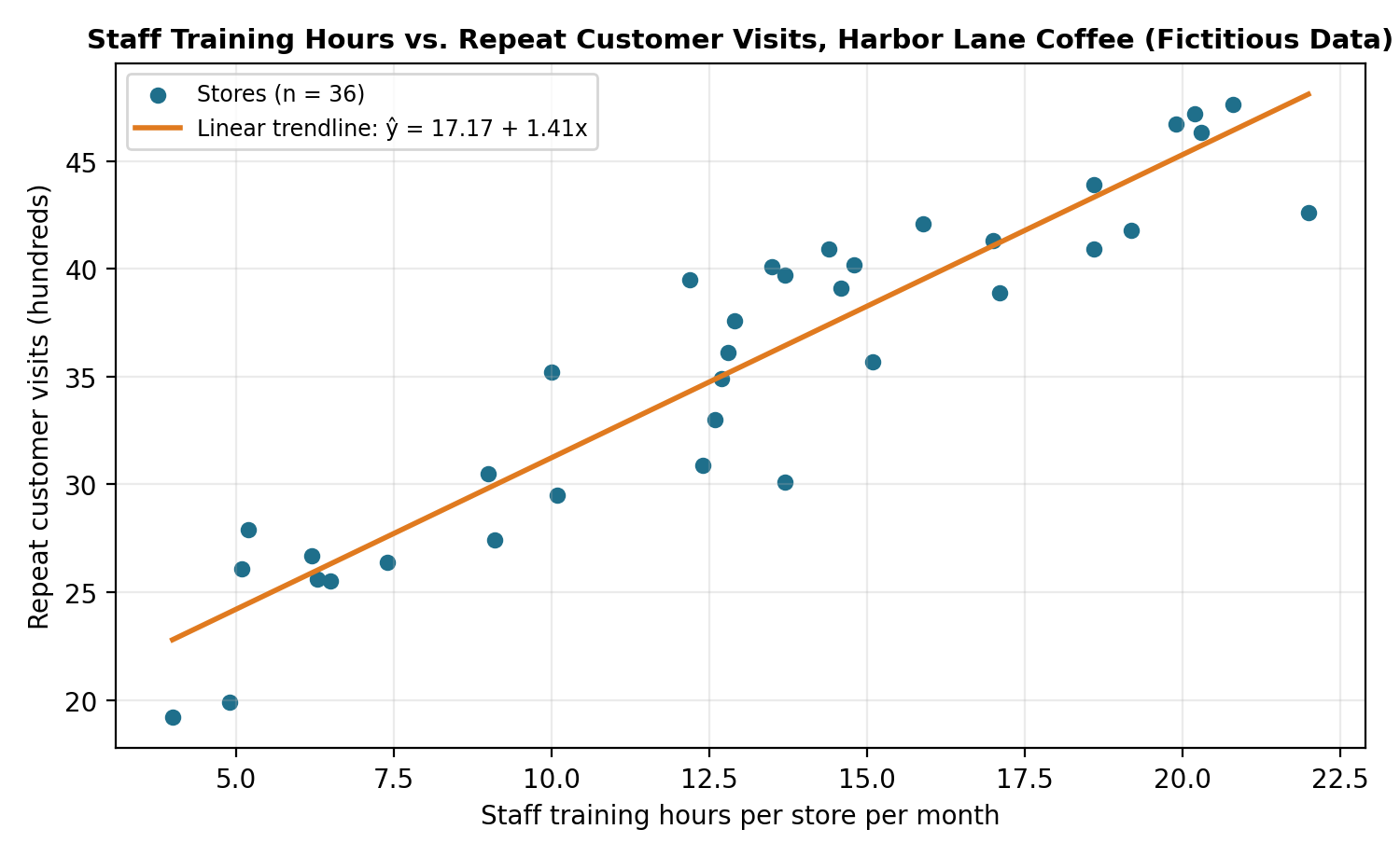
Figure 1. Staff training hours and repeat customer visits at 36 fictitious stores.
Using the Null Hypothesis in Part D
Goodness of fit (D1a). R² is 0.869, meaning about 87% of the variation in repeat visits across the 36 stores is accounted for by training hours. The overall F statistic is 225.88 with a Significance F well below 0.05.
Decision on the null hypothesis (D1b). The p-value for training hours is far below the 0.05 significance level, so we reject H₀: β₁ = 0. Training hours are a statistically significant predictor of repeat visits in this sample.
Equation (D1c). ŷ = 17.17 + 1.41x, where x is monthly training hours and ŷ is predicted repeat visits in hundreds. Each additional training hour is associated with about 141 more repeat visits per month, within the observed range of 4 to 22 hours.
A caution on wording. Rejecting the null shows a significant linear relationship, not that training causes repeat visits. Stores that train more might also differ in other ways, such as location or management, which is a limitation worth naming in D2.
References
Penn State Eberly College of Science. (n.d.). Lesson 2: SLR model evaluation. STAT 501: Regression methods. https://online.stat.psu.edu/stat501/lesson/2/2.12

