Prototype Dashboard Analysis: Home Prices and School Dropout Rates in Eastbrook

Alexis Moreno
Western Governors University
D466: Analyzing and Visualizing Data
Task 1: Creating Data Visualizations
October 5, 2026

Note: This paper is an example for illustration purposes only. Eastbrook, its data set, and all people and companies in it are fictitious, and the data are not WGU's D466 data set. The charts were drawn to show layout and design choices; a real submission must use charts built in Tableau. Do not submit this paper or any part of it for grading. If you need assistance with your D466 Task 1, contact Us on WhatsApp at +1 564 544 6924.

Prototype Dashboard Analysis: Home Prices and School Dropout Rates in Eastbrook
Lakeline Property Group's leadership wants to build reasonably priced housing in areas with well performing schools and low dropout rates. Before commissioning a consulting team to build a full dashboard across the city's five boroughs, I built a prototype for one borough, Eastbrook, using average three-bedroom home prices and average school dropout rates from 2000 to 2024. This paper describes the two factors, explains what the data show, and explains the design techniques used in each visualization.
The Two Main Factors
The first factor is home price, measured as the average price of a three-bedroom home in Eastbrook each year. It tells leadership how affordable the borough is for the families the company wants to serve and what land and construction costs the company may face. The second factor is the school dropout rate, measured as the average percentage of students who leave school before graduating each year. It serves as the prototype's measure of school performance, since a lower rate indicates schools that keep more students through graduation. The two factors pull in different directions for the company's mission: areas with stronger schools may also be the areas where housing is least affordable, which is what the dashboard needs to help leadership weigh.
The Current State of Home Prices
Eastbrook home prices are at the highest point in the data set. The average three-bedroom home cost $467,800 in 2024, up from $212,400 in 2000, an increase of $255,400, or about 120%. Growth was not continuous. Prices peaked at $281,400 in 2006 and fell about 8% to $258,900 by 2008 before recovering. Since 2019, when the average was $389,600, prices have risen about 20% in five years. For leadership, this means that any new construction in Eastbrook would enter a market where affordability has been declining steadily for more than a decade.
Figure 1
Eastbrook Average Three Bedroom Home Price, 2000 to 2024
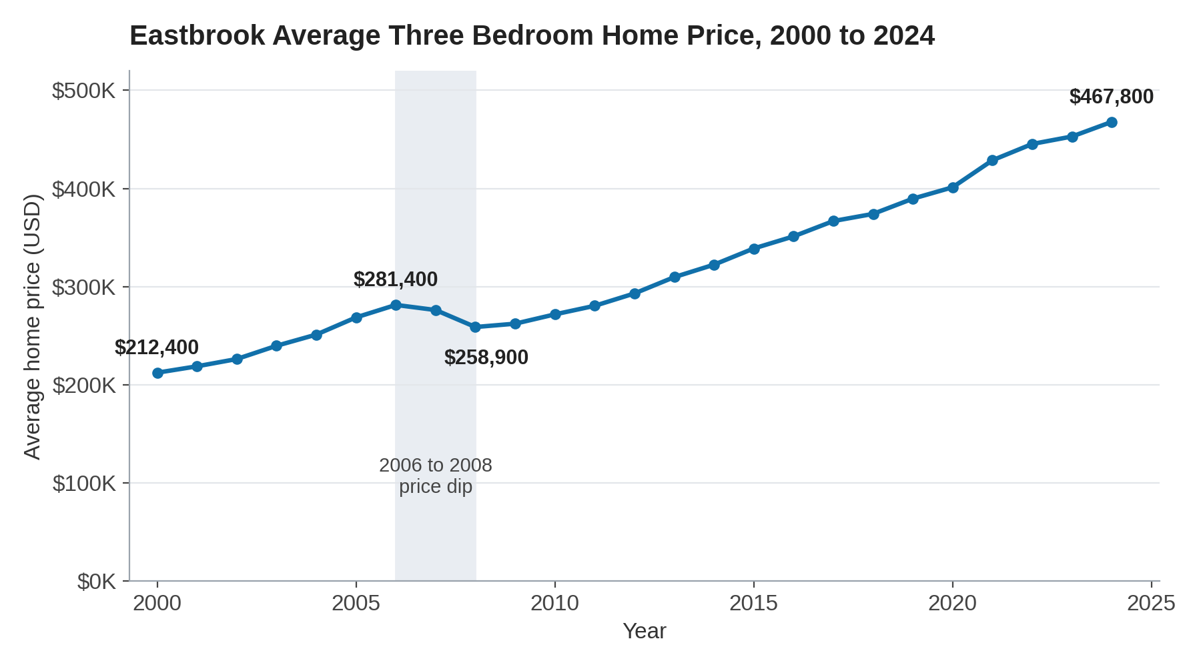
Note. Data are fictitious. Labels mark the first year, the 2006 peak, the 2008 low, and the most recent year. The shaded band marks the 2006 to 2008 price dip.
Accessibility Technique: Readable Text and a Descriptive Title
One design technique in Figure 1 is high contrast text at an enlarged size with a descriptive title. This addresses low vision, a common accessibility issue in which small or faint text is difficult to read. Tableau (n.d.) recommends a contrast ratio of at least 4.5:1 for text and increasing font sizes to make views more accessible. The chart uses dark text on a white background, larger axis and label fonts than Tableau's defaults, and a title that states the measure, place, and years, so a reader does not have to interpret default field names.
Representation Technique: Labels on Key Data Points
A different technique is labeling only four key points: the first year, the 2006 peak, the 2008 low, and the most recent year. Labeling every year would crowd the chart, while labeling none would force leaders to estimate values from the axis. Labeling the turning points lets the chart tell the story of the data directly, showing where prices started, where they dipped, and where they are now.
How a Change in Dropout Rates Would Affect Home Prices
Across the 25 years in the Eastbrook data, years with lower dropout rates had higher average home prices. The dropout rate fell from 24.8% in 2000 to 11.6% in 2024 while home prices more than doubled. A linear trend line fitted to the data has an R squared of 0.93, meaning the dropout rate accounts for about 93% of the variation in home prices in this data set. Its slope indicates that average home price falls by about $16,980 for each one percentage point increase in the dropout rate. Based on this prototype, a borough with dropout rates two points lower would be expected to have average home prices roughly $34,000 higher. This shows a strong association, but it does not prove that dropout rates alone cause price changes. Prices also respond to interest rates, employment, and housing supply, which is why the full dashboard will need the additional predictive factors the consultants will add.
Figure 2
Eastbrook Average Home Price Compared with Average Dropout Rate, 2000 to 2024
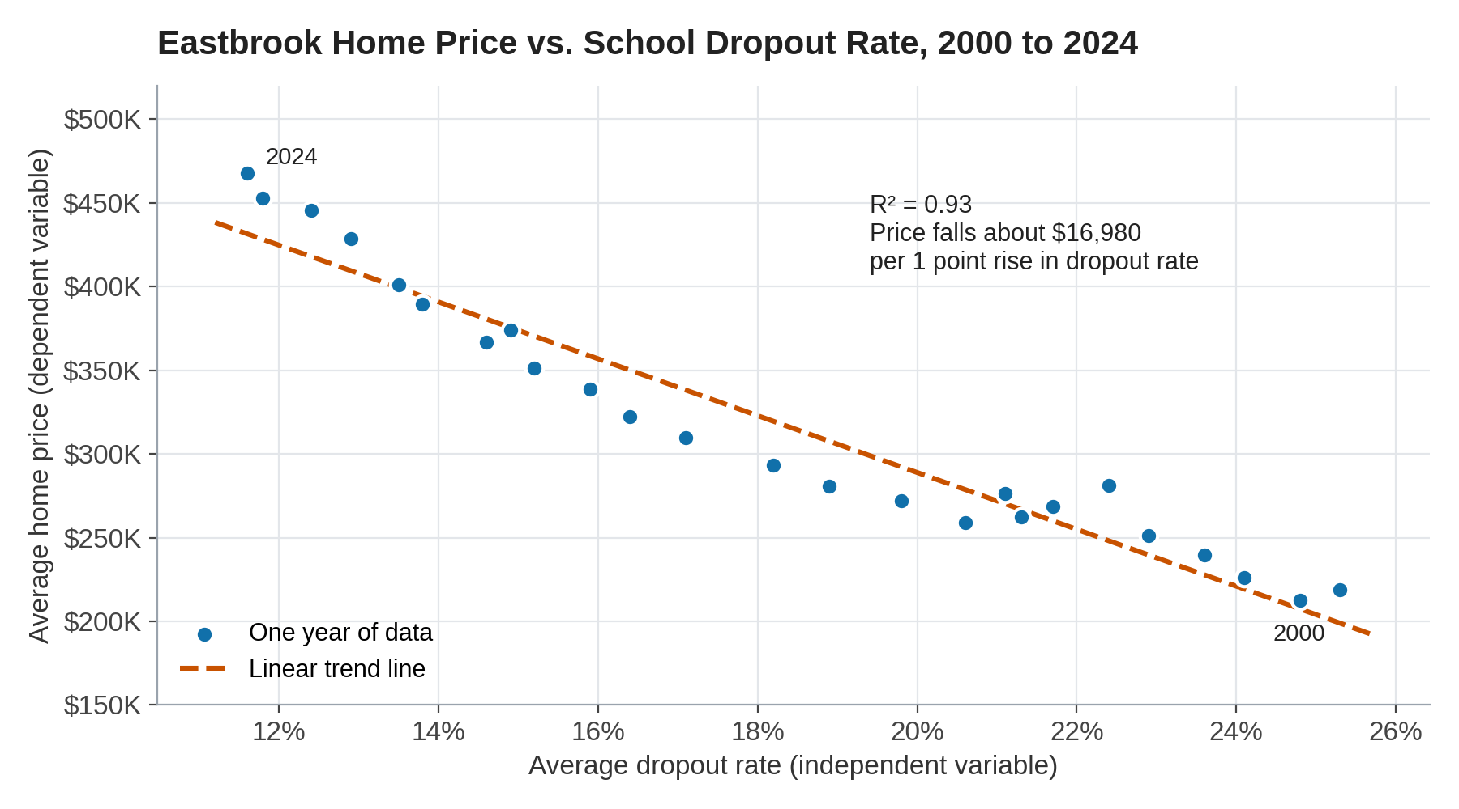
Note. Data are fictitious. Each point represents one year. The dashed line is a linear trend line; R squared = 0.93.
Accessibility Technique: A Color Blind Safe Palette With Secondary Encoding
One design technique in Figure 2 is a color blind safe palette paired with encoding that does not depend on color. This addresses color vision deficiency, which can make common color pairs such as red and green indistinguishable. Tableau (n.d.) suggests its Color Blind palette and advises against relying on color alone to communicate differences. The data points use blue and the trend line uses orange, a pair that remains distinguishable for common forms of color vision deficiency, and the trend line is also dashed and named in the legend, so a reader can tell the two apart even without seeing the colors.
Representation Technique: A Linear Trend Line
A different technique is the linear trend line. The scattered points show that prices are higher when dropout rates are lower, but the trend line makes the direction and strength of that relationship visible at a glance, and the R squared value shown with it tells leaders how closely the data follow the pattern. This turns 25 separate observations into a single, readable story about how the two factors move together.
Conclusion
The Eastbrook prototype shows that home prices are at their highest level in 25 years and that they are strongly associated with lower school dropout rates. For Lakeline Property Group, this confirms that the neighborhoods best aligned with its school performance goal are also the most expensive, which is the central trade-off the full dashboard should help leadership evaluate.
References
Tableau. (n.d.). Author views for accessibility. Tableau Desktop and Web Authoring Help. Retrieved October 5, 2026, from https://help.tableau.com/current/pro/desktop/en-us/accessibility_create_view.htm

